**CIRCULAR**

**CLAW/ SEC/2023/004 DATE: 20.07.2023**

The EC meeting of the alumni association is scheduled to discuss the following agenda below for the academic year 2023- 2024

**Details of the meeting:**

Date: 1/08/2023

Time: 2.00pm- 3.00 pm

Venue: Zoom

Meeting ID: 854 4490 8804

Password: 417537

Meeting Link: <https://us06web.zoom.us/meeting/register/tZEpc2hrjMiGtC0DUNAxB0BaWfSBcc9P5n>

All the members are requested to attend the meeting.

AGENDA:

1. To review the last meeting proceedings
2. To discuss about all the activities by the alumni in the college
3. To discuss about Alumni participation in the meeting
4. To propose the schedule and plan by the alumni association for the upcoming academic year

**Co-ordinator**

**Copy To**

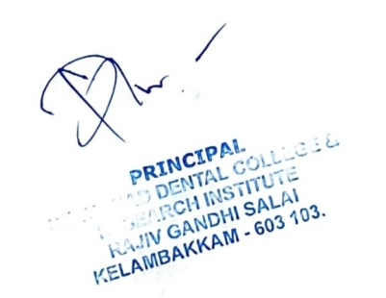Hon’ble Secretary- For Information

Principal

All Committee Members

Office File

**MINUTES OF EC MEETING OF CHETTINAD LEGENDARY ALUMNI WING**

**2023- 2024**

**MEETING- 1**

Date: 1/08/2022

Time: 2.00pm- 3.00 pm

Venue: Zoom- CHETTINAD DENTAL COLLEGE & RESEARCH INSTITUTE

MEMBERS PRESENT:

1. Dr. Subramaniya Prabhu- President
2. Dr. Ragavi- Secretary
3. Dr. Bejoy Zachariah- Joint Secretary
4. Dr. Bhuvaneswari- Treasurer
5. Dr. Aishwarya- EC Member
6. Dr. Gopinath- EC Member
7. Dr. Vigneshwar- EC Member
8. Dr. Rajmanickam- EC Member
9. Dr. Priyadharshini- Ex- Treasurer
10. Dr. Divya Bharathi- Ex- Secretary
11. Dr. Yashini- Ex- Secretary

**AGENDA:**

1. To review the last meeting proceedings
2. To discuss about all the activities by the alumni in the college
3. To discuss about Alumni participation in the meeting
4. To propose the schedule and plan by the alumni association for the upcoming academic year

The meeting was headed by Dr.Prabhu Subramanian, President, Chettinad Legendary Alumni Wing.

Agenda Item were taken up for discussion.

The resolution passed at this time is as follows:

NOTE: Chettinad Legendary Alumni Wing- Meeting-1- 2021

SUB: Chettinad Legendary Alumni Wing- Meeting held on 1/08/2023- Draft meeting regarding

* The draft minutes of meeting for your kind perusal and approval:
* The New members to the association should be added
* The strengthening of the association should be done by batch representatives
* The alumni orientation program should be done for the first years joining in the upcoming academic year (2023- 2024)
* The CDE program should be conducted by the association members for the benefits of students and their career were proposed and discussed

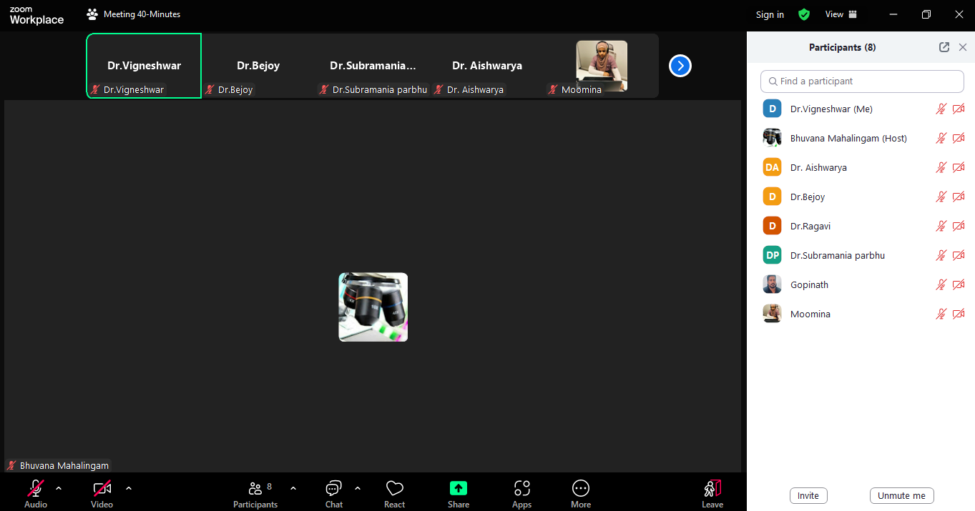

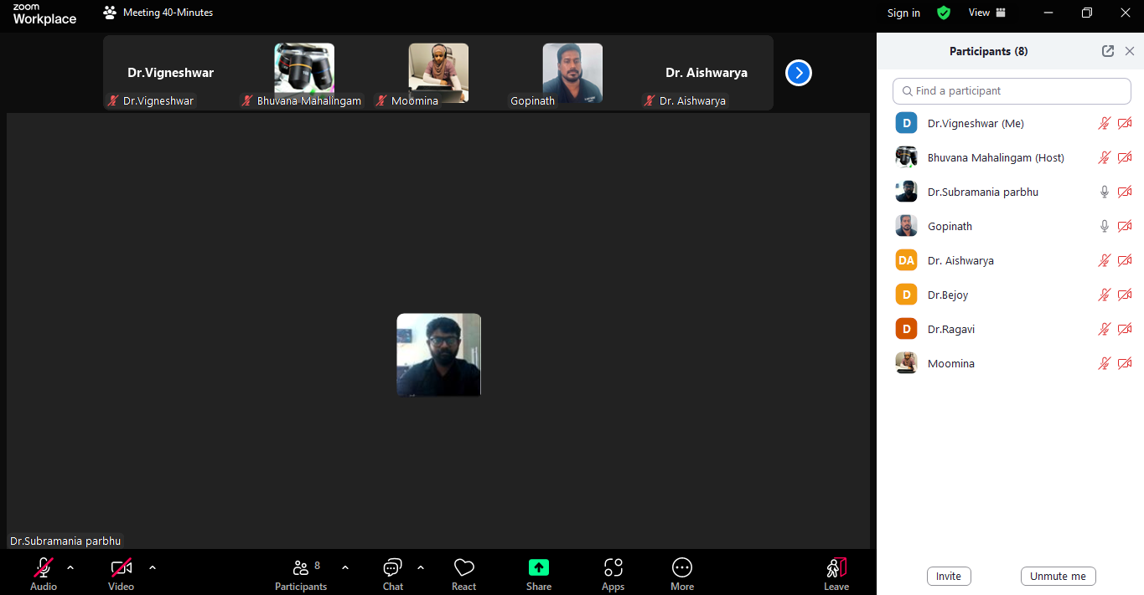

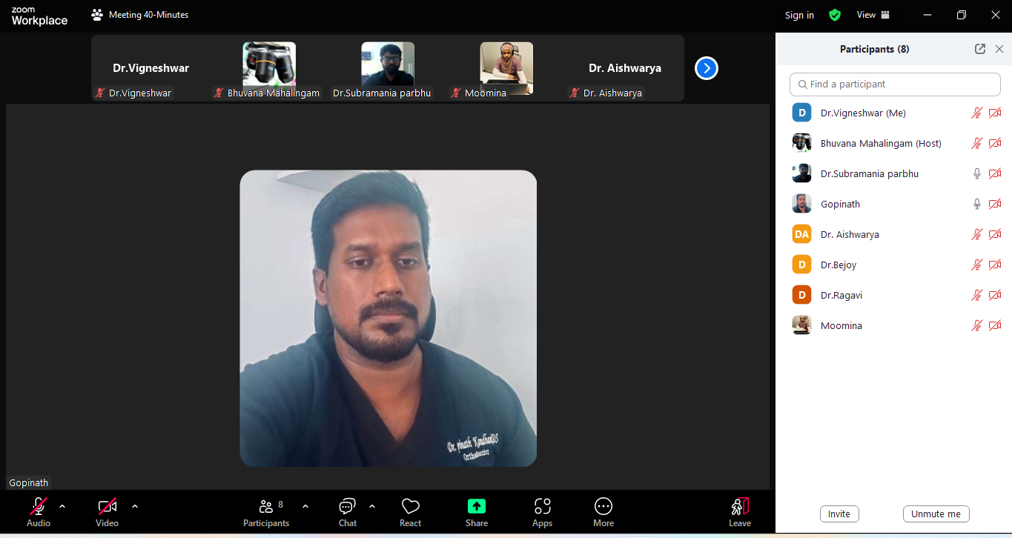



**CIRCULAR**

**CLAW/ SEC/2023/004 DATE: 21.11.2023**

The meeting of the alumni association is scheduled to discuss the following agenda below for the academic year 2023- 2024

**Details of the meeting:**

Date: 21.12.2023

Time: 2.00 pm- 3.00 pm

Venue: Zoom

Meeting Link: <https://us04web.zoom.us/j/79094607202?pwd=98XNAoQe7dq4G3u4g8te0QxGkwMfbS.1>

Meeting ID: 790 9460 7202

All the members are requested to attend the meeting.

**AGENDA:**

1. To review the last meeting proceedings
2. To discuss about all the activities done by the alumni for the year 2023 in the college
3. To discuss about funds of the association.
4. To Plan for AGM for the year 2023- 2024

**Co-ordinator**

**Copy To**

Hon’ble Secretary- For Information



Principal

All Committee Members

Office File

**MINUTES OF EC MEETING OF CHETTINAD LEGENDARY ALUMNI WING**

**2023- 2024**

**MEETING- 2**

Date: 21/12/2023

Time: 2.00pm- 3.00 pm

Venue: Zoom- CHETTINAD DENTAL COLLEGE & RESEARCH INSTITUTE

**MEMBERS PRESENT:**

1. Dr. Subramaniya Prabhu- President
2. Dr. Ragavi- Secretary
3. Dr. Bejoy Zachariah- Joint Secretary
4. Dr. Bhuvaneswari- Treasurer
5. Dr. Aishwarya- EC Member
6. Dr. Gopinath- EC Member
7. Dr. Vigneshwar- EC Member
8. Dr. Rajmanickam- EC Member
9. Dr. Moomina- EC Member

**AGENDA:**

1. To review the last meeting proceedings
2. To discuss about all the activities by the alumni in the college
3. To discuss about Alumni participation in the meeting
4. To propose the schedule and plan by the alumni association for the upcoming academic year

The meeting was headed by Dr. Prabhu Subramanian, President, Chettinad Legendary Alumni Wing.

Agenda Item were taken up for discussion.

The resolution passed at this time is as follows:

NOTE: Chettinad Legendary Alumni Wing- Meeting-1- 2021

SUB: Chettinad Legendary Alumni Wing- Meeting held on 1/08/2023- Draft meeting regarding

* The draft minutes of meeting for your kind perusal and approval:
* The New members to the association should be added
* The strengthening of the association should be done by batch representatives
* The alumni orientation program should be done for the first years joining in the upcoming academic year (2023- 2024)
* The CDE program should be conducted by the association members for the benefits of students and their career were proposed and discussed

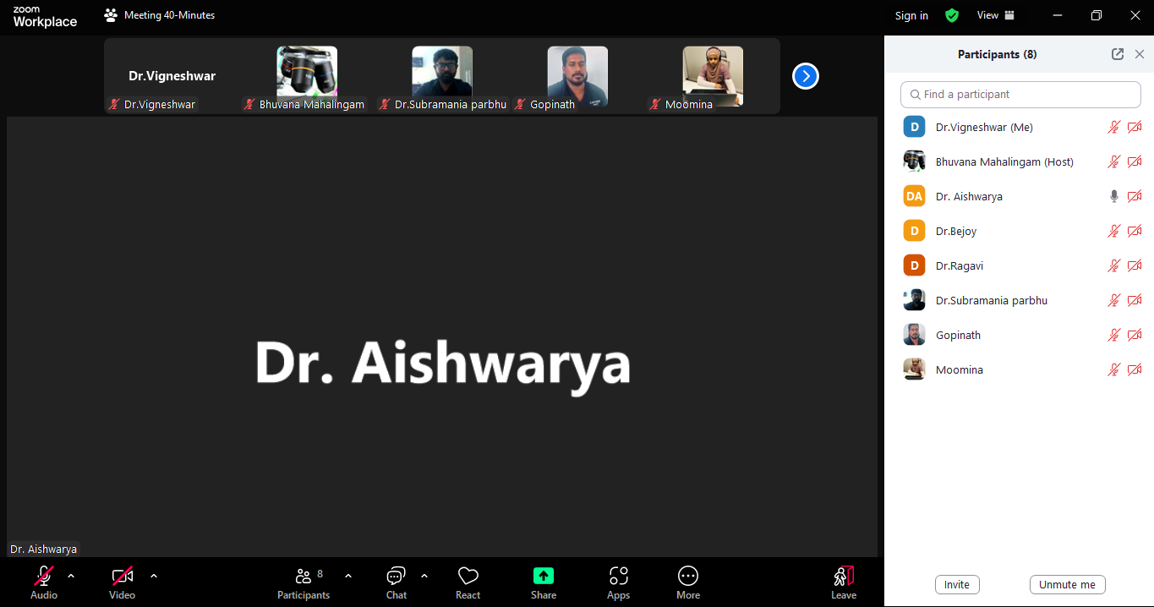

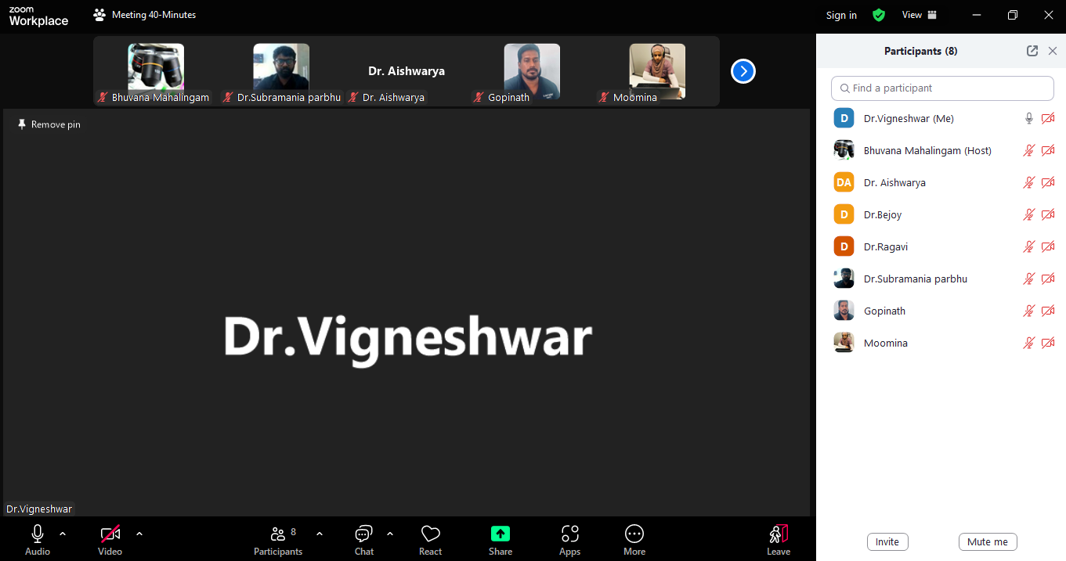

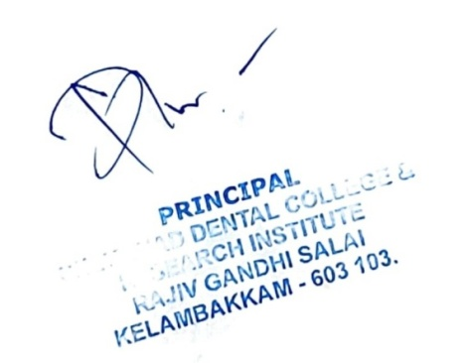

**CIRCULAR**

**CLAW/ SEC/2024/001 DATE: 29.02.2024**

The EC meeting of the alumni association is scheduled to discuss the following agenda below for the academic year 2023- 2024

**Details of the meeting:**

Date: 21.03.2024

Time: 2.30PM- 3.00PM

Venue: Zoom

Meeting Link: <https://us04web.zoom.us/j/79094607202?pwd=98XNAoQe7dq4G3u4g8te0QxGkwMfbS.1>

Meeting ID: 790 9460 7202

All the members are requested to attend the meeting.

AGENDA:

1. To review the last meeting proceedings
2. To discuss about all the activities by the alumni in the college
3. To discuss about Alumni participation in the meeting
4. To propose the schedule and plan by the alumni association for the upcoming academic year

**Co-ordinator**

**Copy To**

Hon’ble Secretary- For Information

Principal

All Committee Members

Office File

**MINUTES OF EC MEETING OF CHETTINAD LEGENDARY ALUMNI WING**

**2023- 2024**

**MEETING- 3**

Date: 21/03/2024

Time: 2.00pm- 3.00 pm

Venue: Zoom- CHETTINAD DENTAL COLLEGE & RESEARCH INSTITUTE

**MEMBERS PRESENT:**

1. Dr. Subramaniya Prabhu- President
2. Dr. Ragavi- Secretary
3. Dr. Bejoy Zachariah- Joint Secretary
4. Dr. Bhuvaneswari- Treasurer
5. Dr. Aishwarya- EC Member
6. Dr. Gopinath- EC Member
7. Dr. Vigneshwar- EC Member
8. Dr. Rajmanickam- EC Member
9. Dr. Moomina- EC Member
10. Dr. Nyklesh- Member
11. Dr. Snega- Member

**AGENDA:**

To review the last meeting proceedings

To discuss about all the activities by the alumni in the college

To discuss about Organizing Annual General Body meeting in the month of March, 2024

To discuss the schedule and plan for AGM by the alumni association

The meeting was headed by Dr. Prabhu Subramanian, President, Chettinad Legendary Alumni Wing.

Agenda Item were taken up for discussion.

The resolution passed at this time is as follows:

NOTE: Chettinad Legendary Alumni Wing- Meeting-3- 2024

SUB: Chettinad Legendary Alumni Wing- Meeting held on 13/02/2024- Draft meeting regarding

* The draft minutes of meeting for your kind perusal and approval:
* The New members to the association should be added
* The strengthening of the association should be done by batch representatives
* The CDE program should be conducted by the association members for the benefits of students and their career were proposed and discussed
* The Annual Grand Meeting should be held with massive crowd and more participants than previous year
* Best Alumni and Life Time Achievement award list to be prepared for presentation in AGM
* All the EC members along with faculty members of CLAW should co- ordinate in preparation of AGM- momentum, return gifts, certificates, Lunch.

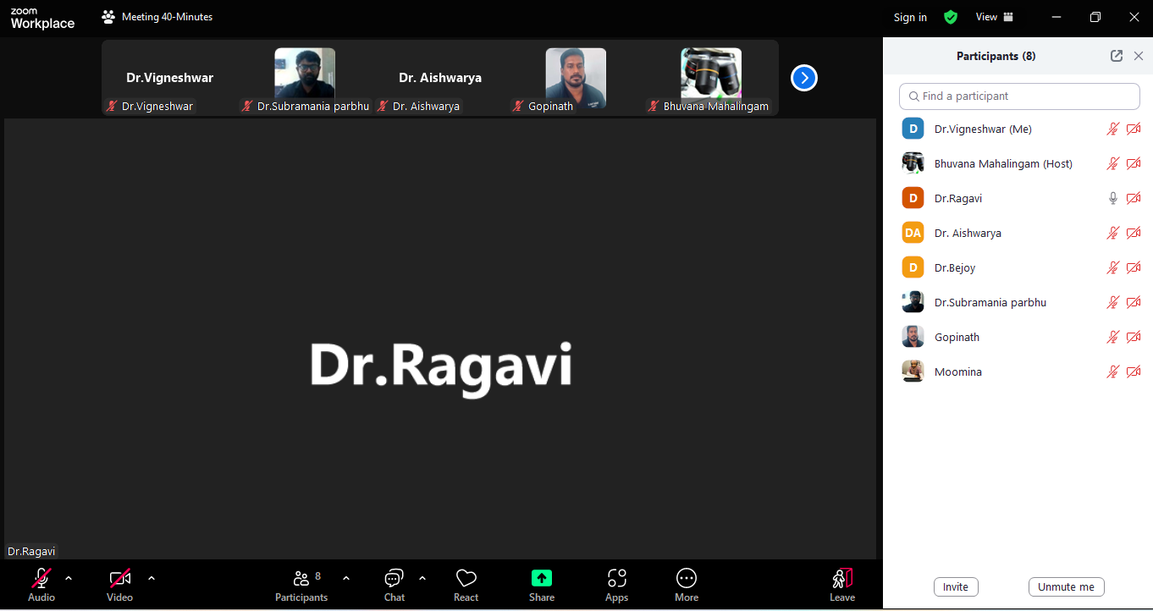

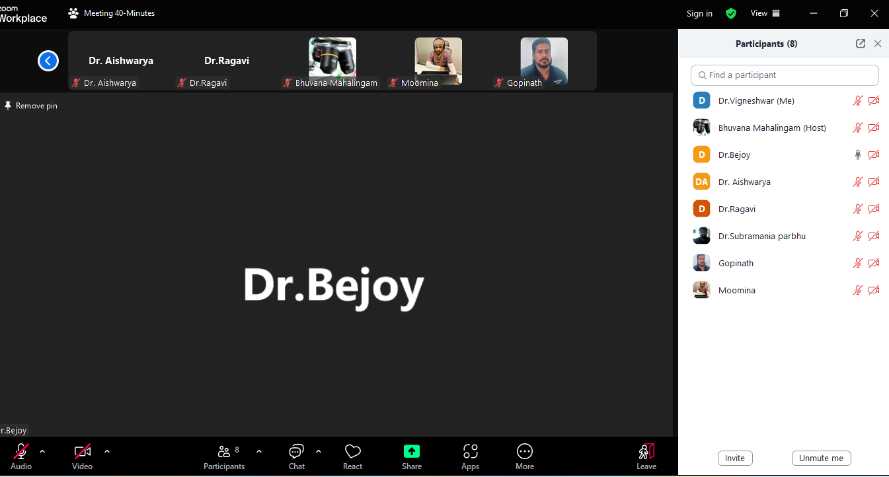



**CIRCULAR**

**CLAW/ SEC/2024/003 DATE: 30.04.2024**

The EC meeting of the alumni association is scheduled to discuss the following agenda below for the academic year 2023- 2024

**Details of the meeting:**

Date: 16/05/2024

Time: 2.00pm- 3.00 pm

Venue: Zoom

Meeting ID: 854 4490 8804

Password: 417537

Meeting Link: <https://us06web.zoom.us/meeting/register/tZEpc2hrjMiGtC0DUNAxB0BaWfSBcc9P5n>

All the members are requested to attend the meeting.

AGENDA:

1. To review the last meeting proceedings
2. To discuss about annual grand meeting happened on 06.03.2024
3. To discuss about Audited statement for the year 2023- 24
4. To propose the schedule and plan by the alumni association for the upcoming academic year

**Co-ordinator**

**Copy To**



Hon’ble Secretary- For Information

Principal

All Committee Members

Office File

**MINUTES OF EC MEETING OF CHETTINAD LEGENDARY ALUMNI WING**

**2023- 2024**

MEETING- 4

Date: 16/05/2024

Time: 2.00pm- 3.00 pm

Venue: Zoom- CHETTINAD DENTAL COLLEGE & RESEARCH INSTITUTE

**MEMBERS PRESENT:**

1. Dr. Subramaniya Prabhu- President
2. Dr. Ragavi- Secretary
3. Dr. Bejoy Zachariah- Joint Secretary
4. Dr. Bhuvaneswari- Treasurer
5. Dr. Aishwarya- EC Member
6. Dr. Gopinath- EC Member
7. Dr. Vigneshwar- EC Member
8. Dr. Rajmanickam- EC Member
9. Dr. Moomina- EC Member
10. Dr. Nyklesh- Member
11. Dr. Snega- Member

**AGENDA:**

1. To review the last meeting proceedings
2. To discuss about all the activities by the alumni in the college
3. To discuss about Organizing Annual General Body meeting in the month of March, 2024
4. To discuss the schedule and plan for AGM by the alumni associationAs per Bye- law of the association, the tenure of the existing committee members is getting over.
5. To collect willingness/ resignation of their current position as the office bearers is to be discussed.
6. To discuss points relevant to strengthening the association

The meeting was headed by Dr. Prabhu Subramanian, President, Chettinad Legendary Alumni Wing.

Agenda Item were taken up for discussion.

The resolution passed at this time is as follows:

NOTE: Chettinad Legendary Alumni Wing- Meeting-3- 2024

SUB: Chettinad Legendary Alumni Wing- Meeting held on 13/02/2024- Draft meeting regarding

* The draft minutes of meeting for your kind perusal and approval:
* The New members to the association should be added
* The strengthening of the association should be done by batch representatives
* The CDE program should be conducted by the association members for the benefits of students and their career were proposed and discussed
* The Annual Grand Meeting should be held with massive crowd and more participants than previous year
* Best Alumni and Life Time Achievement award list to be prepared for presentation in AGM
* All the EC members along with faculty members of CLAW should co- ordinate in preparation of AGM- momentum, return gifts, certificates, Lunch.

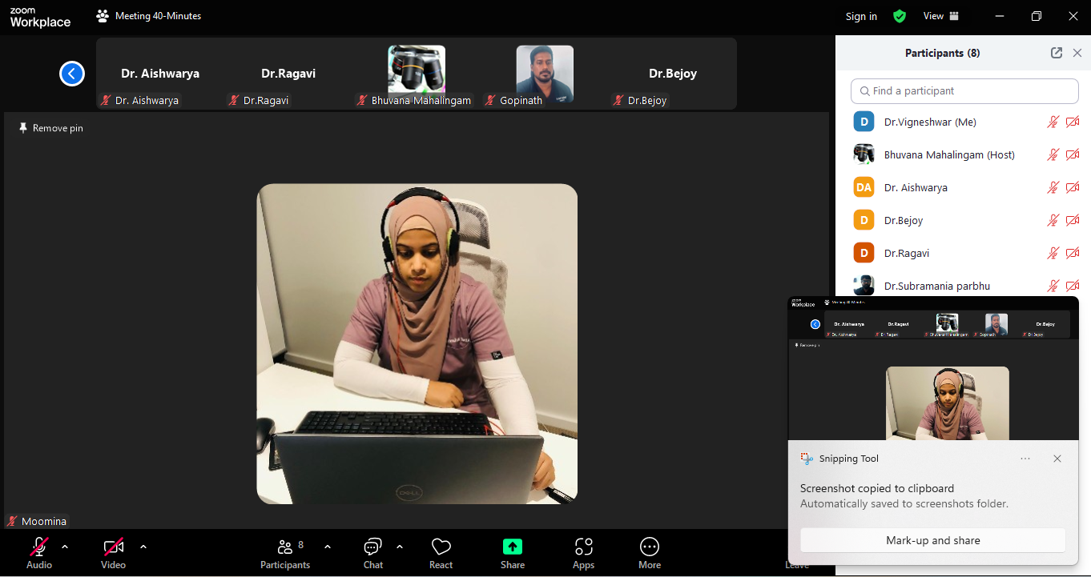

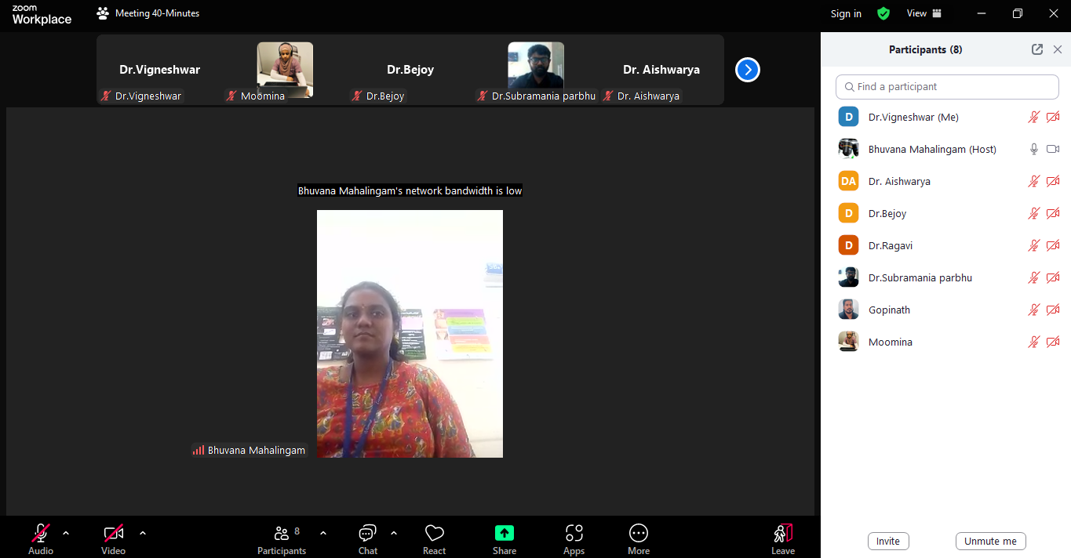



**MINUTES OF MEETING OF CHETTINAD LEGENDARY ALUMNI WING**

**ANNUAL GENERAL BODY MEETING**

**VENUE:** HYBRID Mode: E- block, lecture hall- 14 at Chettinad dental college & research institute & zoom application

**TIME:** 10.00am- 1.00 pm

**DATE:** 06/03/2024

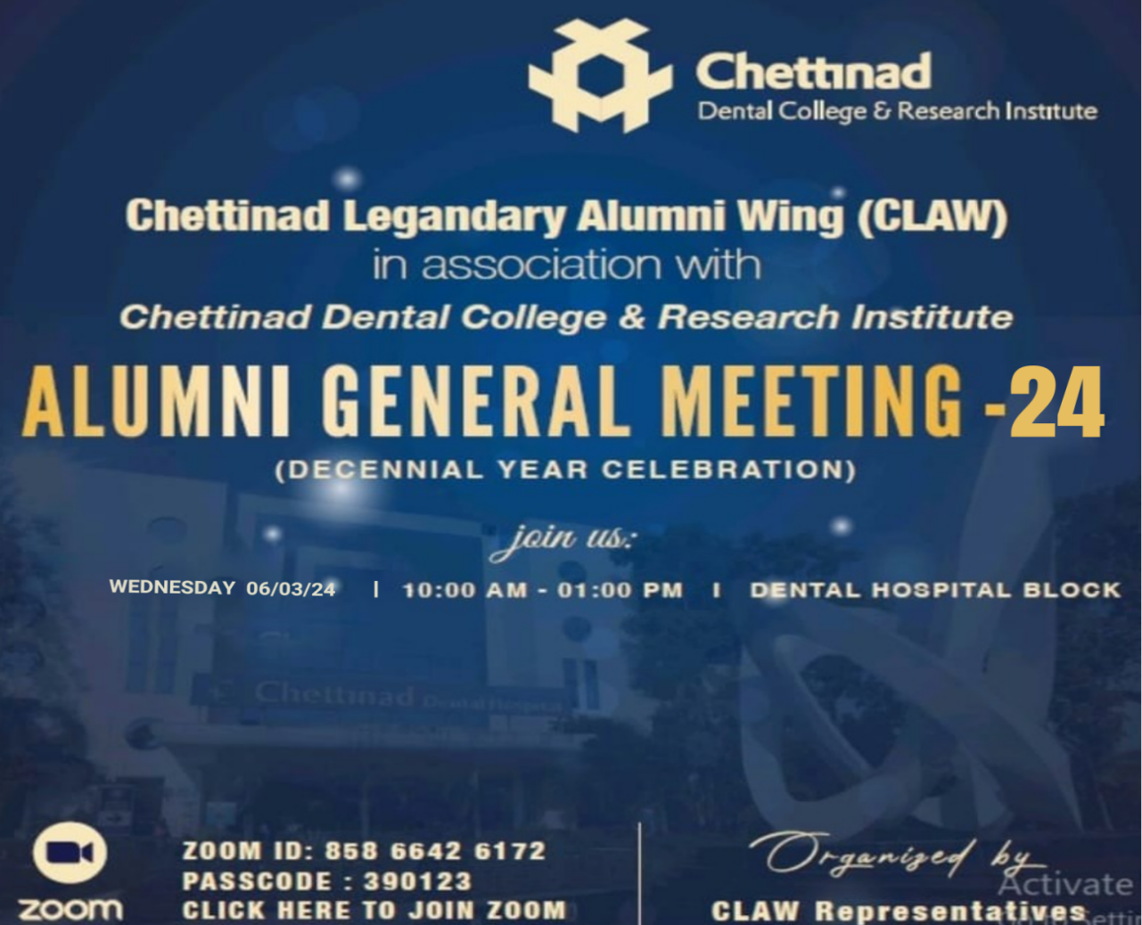

**ZOOM DETAILS:**

Chettinad Academy of Research & Education is inviting you to a scheduled Zoom meeting.

Topic: CLAW Alumni Meet AGM

Time: March 06, 2024 10:00 AM Mumbai, Kolkata, New Delhi

**Zoom Meeting link:**

<https://us02web.zoom.us/j/85866426172?pwd=eEVyZXJBSW5UYmU1Wm5zVWtBYWxjZz09>

**Meeting ID:** 858 6642 6172

**Passcode:** 390123

**MEMBERS ATTENDED:**

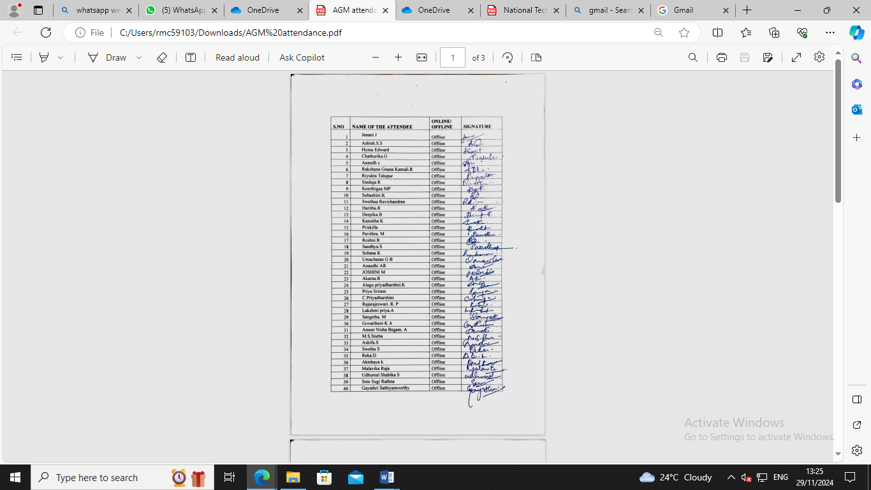

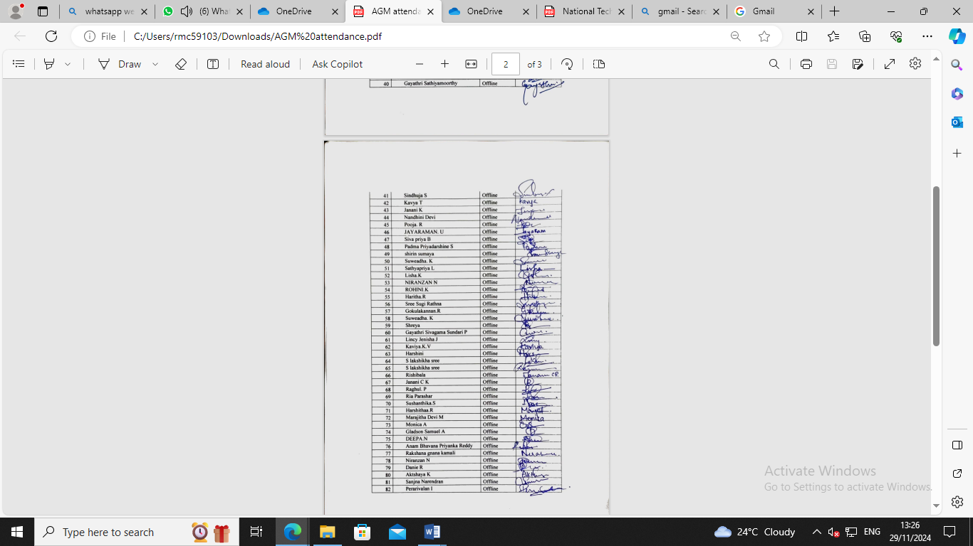

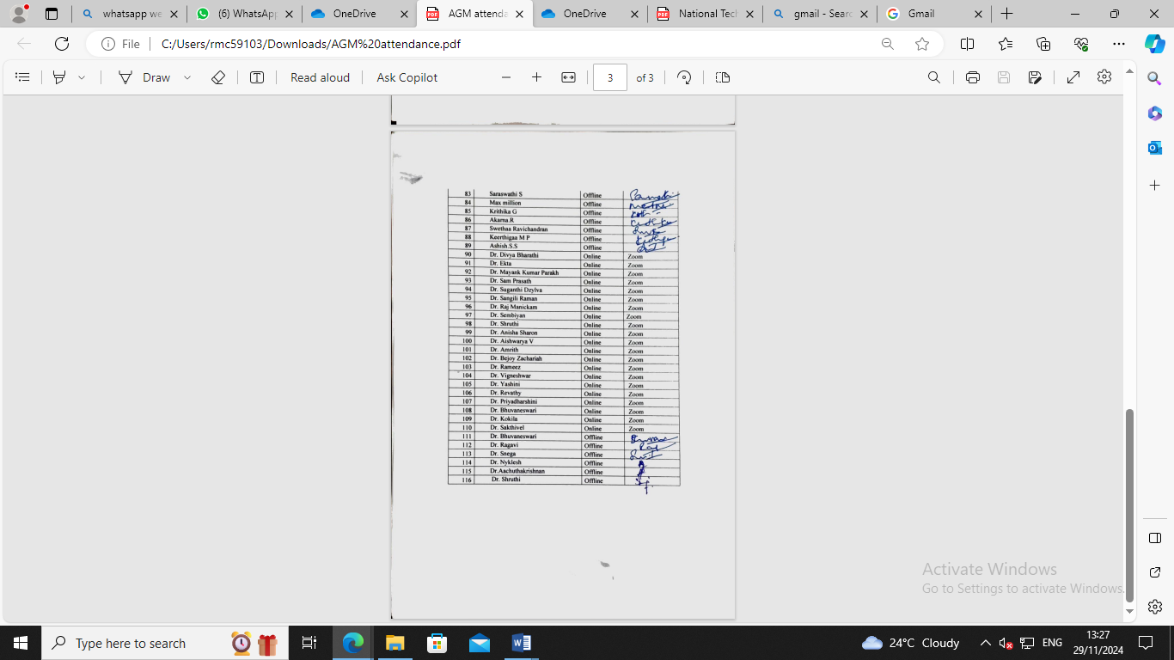

**AGENDA:**

1) To strengthen the bond of CLAW

2) Role of alumni participation in CDCRI (Camp, CDE programs, etc)

3) To improve alumni page in our official college website

4) To get library access for alumni members

5) To motivate current students for good rapport with CLAW

6) To organize/conduct upcoming CDE programs and health camps

7) To setup a new name board for renewal purpose

8) To maintain e-register/form to keep track of all the alumni

9) To discuss about adding or modifying the existing members

10) Future plans for upgrading the CLAW

The meeting was headed by Dr. Ragavi, Secretary, Chettinad Legendary Alumni Wing.

Agenda Item were taken up for discussion.

The resolution passed at this time is as follows:

NOTE: Chettinad Legendary Alumni Wing- AGM- 2024

SUB: Chettinad Legendary Alumni Wing- Annual grand meeting held on 06/03/2024- Draft meeting regarding

The draft minutes of meeting for your kind perusal and approval:

The meeting started by 10.00 am. Dr. Bhuvaneswari, Treasurer listed out the agenda of the meeting. The Secretary, spoke out future plans of the association- for the financial year 2024- 25 as follows:

|  |  |  |
| --- | --- | --- |
| **S.NO** | **TYPE OF EVENT/ PROGRAM** | **DATE** |
| 1 | AGM (2023- 2024) | March |
| 2 | EC Meeting | 11/04/ 2024 |
| 3 | Election Process | May |
| 4 | Election | 15/06/2024 |
| 5 | Alumni Programs | To be co ordinated with Alumni staffs in each dept |
| 6 | Annual Filing | Within 30/04/2024 |
| 7 | EC Meeting | 27/07/2024 |
| 8 | EC Meeting | 21/09/2024 |
| 9 | EC Meeting | 14/12/2024 |

There were few fun activities performed by passed out CRIs. Few students were awarded for their academic excellence.

* Alumni bond need to improve by adding all batch alumni was discussed
* Dr. Ragavi was recommended as Secretary and Dr. Bhuvana was recommended as treasurer by all the EC members
* Alumni contribution for the upcoming year was discussed and also interaction with the current students can be achieved by conducting programs and sessions.
* Alumni Contribution of books and funds was also discussed and proper step will be taken by the society members.
* No of programs/ events/ camp to be conducted by alumni for the student’s support was also discussed.

**GEOTAGGED PHOTOGRAPHS:**

